Upper Rocky SL083 Conductivity and Sources
Jan 14, 2019
Table of Contents
Purpose 1
Watershed description 2
Data 4
Monitored Sites 5
Analysis 6
Water Quality Issues Summary 10
Cause Determination Plans and Status 10
Mitigation Plans and Status 11
Stormwater Management Recommendations from The Nature Conservancy
12
References 13

Purpose
- Create awareness of year-round high conductivity at Site SL083, Upper Rocky Run.
- Determine the source(s) of this high conductivity.
- Establish that high conductivity is due to salt.
- Initiate discussions on how to mitigate this issue.

Watershed description

Stream map
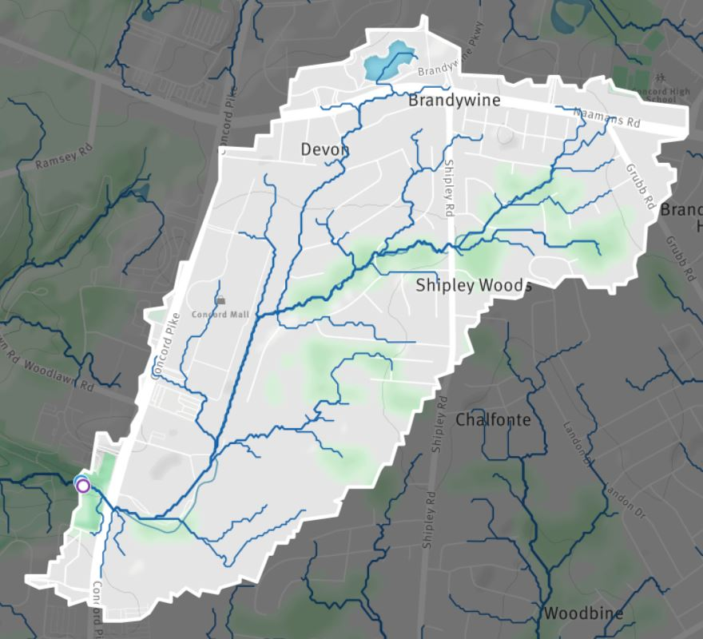

Structures - buildings, parking lots
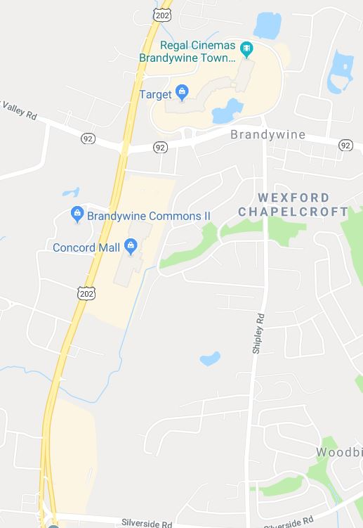
Upper Rocky Run drains Concord Mall, part of Brandywine Town Center and Concord Square Shopping Center and Route 202 itself. Concord Square Shopping Center has a large catch basin whose overflow enters Rocky just east of 202. These locations contribute to high run off.
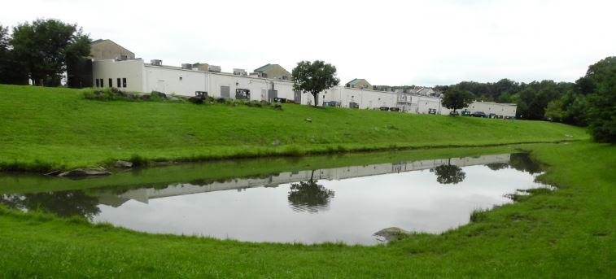

Data
Mayfly Logger conductivity (CND) data from The Nature Conservancy site SL083 is employed. Access via Historic data column at http://fsnhpsensors.dreamhosters.com/charts_main_SL083.php.
Historical Rocky Run conductivity data is provided by the Delaware Nature Society from site BC5.
Conductivity, pH and Chloride (CL) data from site visits to pipes entering the concrete Rocky Run stream channel behind the Concord mall has been collected in attempt to determine source(s) of high summer conductivity. https://docs.google.com/spreadsheets/d/1I_Uw5TrHe0pJA9NZR8BkknYaZ-Yqh1a_OfonxUClcgo/edit#gid=0
High conductivity is indicative of dissolved ions like chloride, nitrate, sulfate, phosphate, sodium, magnesium, calcium, iron, and aluminum. Such ions could be the result of road salt, fertilizers, types of rock in stream bed and more.
Conductivity for healthy water ranges from 120uS/cm to 400uS/cm in Delaware Piedmont Streams (uS = “micro Siemens”). Concern exists if 650uS/cm is exceeded.
https://irma.nps.gov/DataStore/DownloadFile/554895
Chloride (Cl-, the anion component of NaCl, road salt/table salt) is being measured to determine if it contributes to high conductivity. Conductivity spikes (up to 40,000 uS/cm) were observed in association with winter storms in 2017-2018. Through professional field and data analysis, salt flushes from roads and parking lots were determined to be the most likely source of the conductivity spikes. Winter time conductivity spikes during and after storms are a common well-documented occurrence (see Kaushal et al., 2018; Kaushal et al. 2005) in which melting snow and ice carry salt into nearby streams.

Monitored Sites
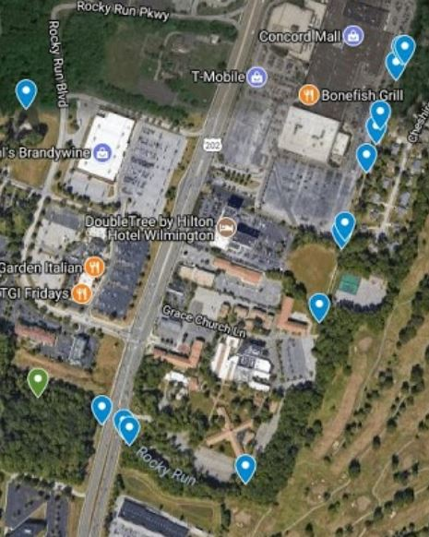
## SiteID Location
## 1 SL083 Rocky Run Upstream
## 2 SL083A-1 Bridge Pipes 1
## 3 SL083A-2 Bridge Pipes 2
## 4 SL083A-3 Bridge Pipes 3
## 5 SL083A-4 Bridge Pipes 4
## 6 SL083A-5 Bridge Pipes 5
## 7 SL083B Talley Pond
## 8 SL083C Golf Course
## 9 SL083D Law School Outfall
## 10 SL083E Sears1
## 11 SL083F Sears2
## 12 SL083G-1 Sears3 Pipe1
## 13 SL083G-2 Sears3 Pipe2
## 14 SL083H Sears4
## 15 SL083I Sears5
## 16 SL083J Sears6
## 17 SL083K Top Culvert
## 18 SL083L Neighborhood

Analysis
Analysis employs plots of conductivity readings over time. Plot trend lines and healthy limit lines suggest improvement or degradation of conductivity. Health limits are established by agencies like EPA, DNREC, TNC, DNS or WCWS. The legends for health limits indicate high or low or range, the limit value and the agency used. Commentary further explains the plot and the significance of changes in conductivity readings.
Historically Rocky Run Conductivity has been increasing year to year. The red data points indicate that healthy limits are exceeded.
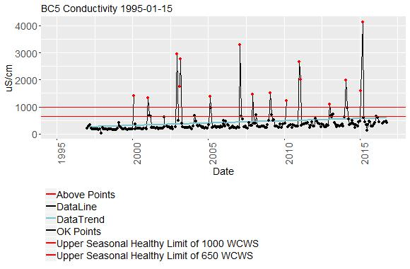
Daily Mean Conductivity for Site SL083 is plotted.
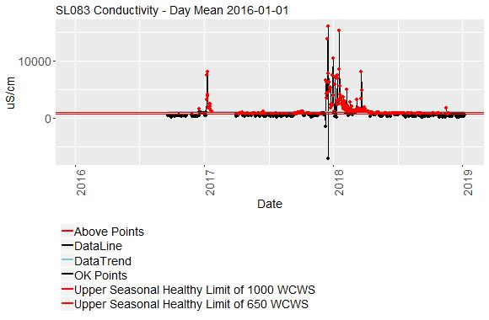
During the winter when road salt is applied, the daily mean plot shows conductivity spikes that far exceed healthy stream values (up to 40,000 uS/cm), after certain weather events. Such events include snow melts and rain after salting when no snow occurred. As mentioned, it is likely that road salt is responsible for high conductivity. Additional chloride testing supports this hypothesis.
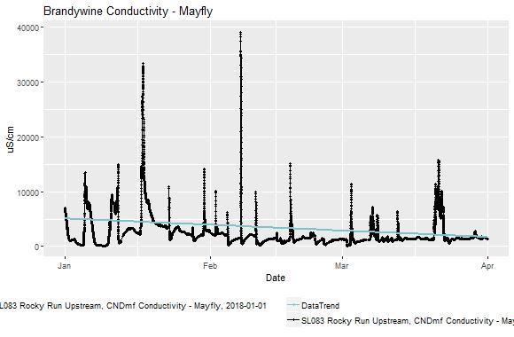
In the summer, many conductivity readings remain above healthy values but trend downward. Rain events dilute the conductivity as indicated by downward spikes.
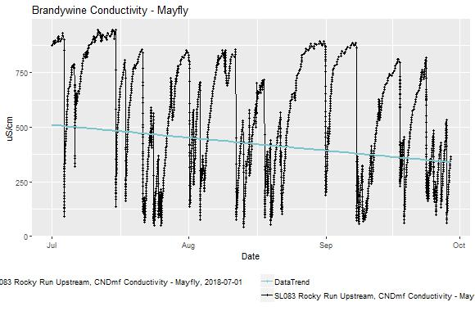

It seems like salt is still getting into the stream even in the summer. To determine the source(s) of high summer conductivity, additional sites (pipes and outfalls from parking lots adjacent to Rocky Run) upstream of SL083 were sampled. During summer and fall sampling of these pipes and outfalls many different locations showed conductivity above 650 uS/cm and several pipes and outfalls were above 1300 uS/cm on multiple occasions. See https://docs.google.com/spreadsheets/d/1I_Uw5TrHe0pJA9NZR8BkknYaZ-Yqh1a_OfonxUClcgo/edit#gid=0. One pipe, SL083I, exhibited especially high conductivity (>4500 uS/cm) and became the focus of further study.
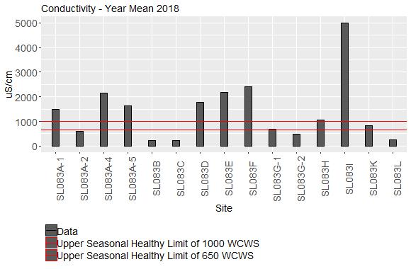

SL083I Readings
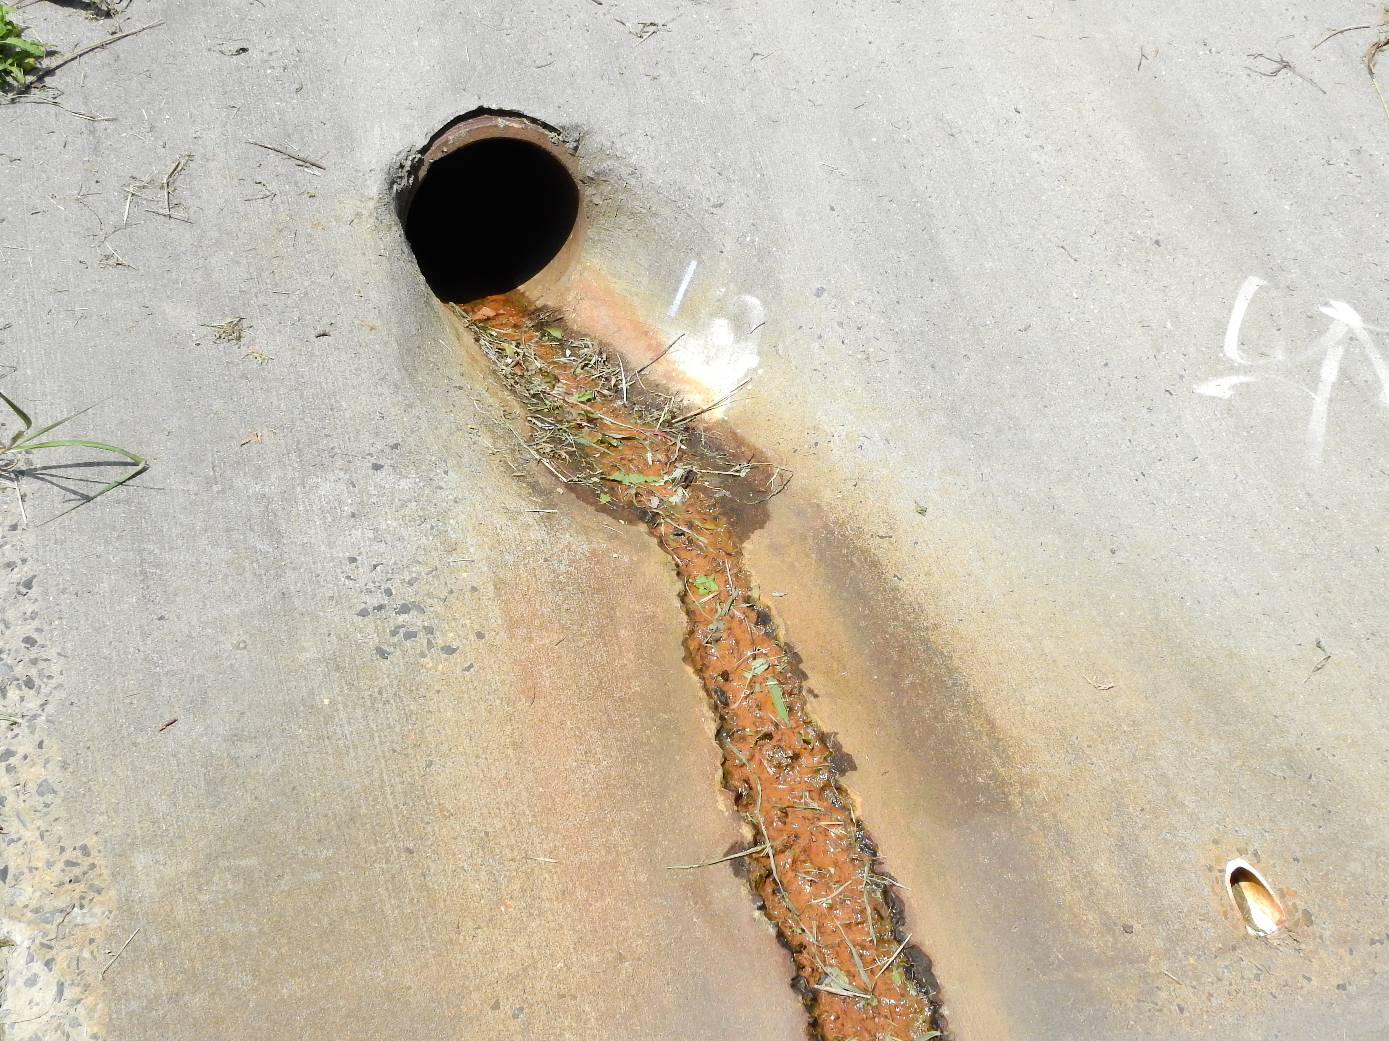
Chloride is high as well, suggesting that salt is a significant component of high conductivity.
PH reading is very basic at 9.2. The cement around the pipe is disintegrating.
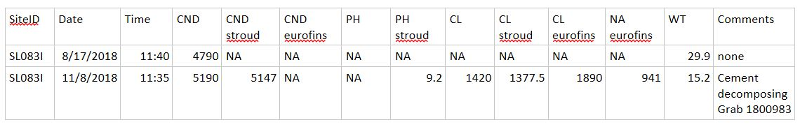

SL083I Lab Results
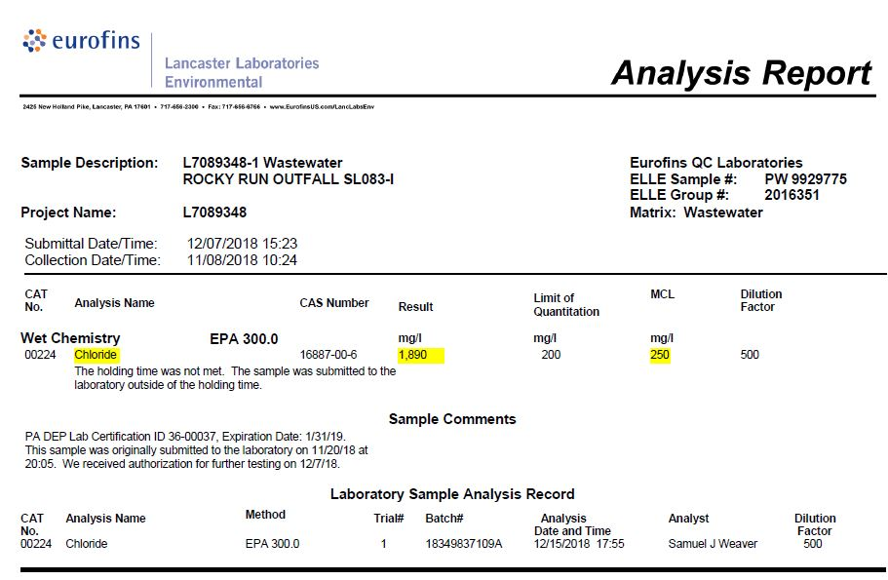
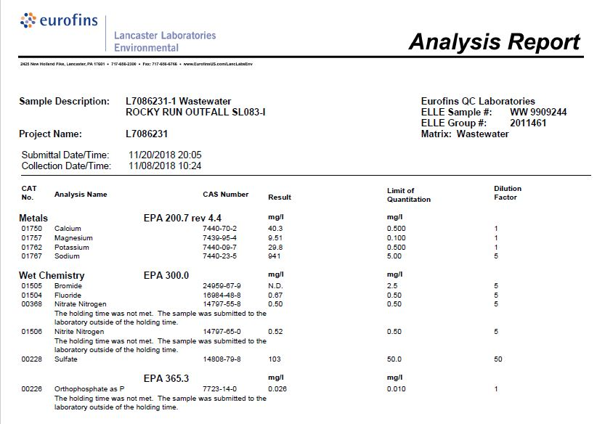

Water Quality Issues Summary
Conductivity is the water quality parameter that demands our attention at the Rocky Run SL083 site.
Results to date show that high conductivity throughout the year can be explained by road salt in mall and other parking lots.
In the summer, conductivity remains above healthy stream limit when no road salt is being added. Currently, the sources(s) of high summer conductivity are being investigated. Flushing of salt deposited during the winter is a strong possibility.
Several pipes presumably coming from the Concord Mall exhibit high summer conductivity levels. Chloride is high also, thus salt is a significant contributor.
One pipe has a pH issue (>9).

Cause Determination Plans and Status
The plan is to continue to investigate up stream potential point sources to explain why conductivity remains high in the summer.
The same point sources (SL083A through SL083L) will be monitored during the road salt season to identify the most significant conductivity sources.
Additional conductivity, chloride and sodium measurements will be performed to further confirm salt as the source of high conductivity.

Mitigation Plans and Status
Mitigation plans involve providing this report to District 2 County Council member Dee Durham and Michael Harris Stormwater & Environmental Programs Manager for New Castle County, and other interested parties.

Discussions to include:
- Conductivity issue awareness
- Continued monitoring
- Cause determination next steps like discussions with property owners
- Desire for additional laboratory analysis to determine chemically what is in SL083I samples
- Possible mitigation discussions

As a state listed impaired waterway, Rocky Run requires a Total Maximum Daily Load (TMDL) to be developed to reduce pollution levels and meet water quality standards as per the Clean Water Act. Stream Stewards, a Citizen Monitoring Program, is a potential partner for the Delaware Department of Natural Resources and Environmental Control (DNREC) to assist with Pollution Control Strategies (PCSs) for TMDLs and to increase education and awareness of water quality issues and promote watershed stewardship in the Brandywine-Christina watershed.

Stormwater Management Recommendations from The Nature Conservancy in Delaware

The Nature Conservancy recommends a comprehensive approach to stormwater management and pollution reduction in the Rocky Run subwatershed to address potential water quality impacts from runoff in developed areas upstream of where Rocky Run flows into the Beaver Valley unit of First State National Historical Park. This would include an assessment of existing stormwater management features such as detention basins, to examine their current effectiveness, as well as the potential for making retrofits to improve their ability to increase infiltration and protect water quality.

In addition to improving existing features, The Nature Conservancy promotes the use of green infrastructure in plans for new development projects and land use changes in the Rocky Run subwatershed. Green infrastructure is an economically sustainable way to mitigate the impacts of impervious surface cover, and also provide socioecological benefits. Green infrastructure elements such as native plantings in rain gardens and bioswales in residential and commercial development sites improve water quality and provide other benefits to local residents such as flood control and improved air quality, while also increasing habitat value for native wildlife. (https://www.epa.gov/green-infrastructure/what-green-infrastructure)

Recently, The Nature Conservancy established a network of 24 urban conservation programs in the U.S. with the goal of using natural solutions to address many of the challenges facing urban areas, creating more livable communities and a world where people and nature thrive together. In Greater Wilmington, our strategies include promoting nature-based solutions to address a wide variety of social and environmental challenges and demonstrating the efficacy of our projects through sound research and evaluation. We are also working to inspire the next generation of environmental stewards and engage residents in citizen science research.
(https://www.nature.org/en-us/what-we-do/our-priorities/build-healthy-cities/)

Through the Stream Stewards program, we are monitoring water quality in five streams, including Rocky Run, that flow through the Beaver Valley unit of First State National Historical Park into Brandywine Creek, the sole source of drinking water for residents of Wilmington and other parts of New Castle County. The Nature Conservancy is working in nearby cities like Philadelphia and Washington D.C. to use green infrastructure to address stormwater pollution. (https://www.nature.org/en-us/about-us/where-we-work/united-states/pennsylvania/stories-in-pennsylvania/natural-solutions-to-stormwater/)
(https://www.nature.org/en-us/about-us/who-we-are/our-people/mark-tercek/historic-(catholic-church-cemetery-employs-green-infrastructure-t/)
We are interested in partnering with private landowners, water utilities, municipalities and state agencies to influence policy and practice that will result in cleaner water for Delaware.

References
Kaushal SS, et al. (2005) Increased salinization of fresh water in the northeastern United States. Proc Natl Acad Sci USA 102:13517-13520.
Kaushal, SS; Groffman, PM; Likens, GE; et al. 2018. Increased salinization of fresh water in the northeastern United States. PROCEEDINGS OF THE NATIONAL ACADEMY OF SCIENCES OF THE UNITED STATES OF AMERICA Volume: 102 Issue: 38 Pages: 13517-13520 Published: SEP 20 2005

