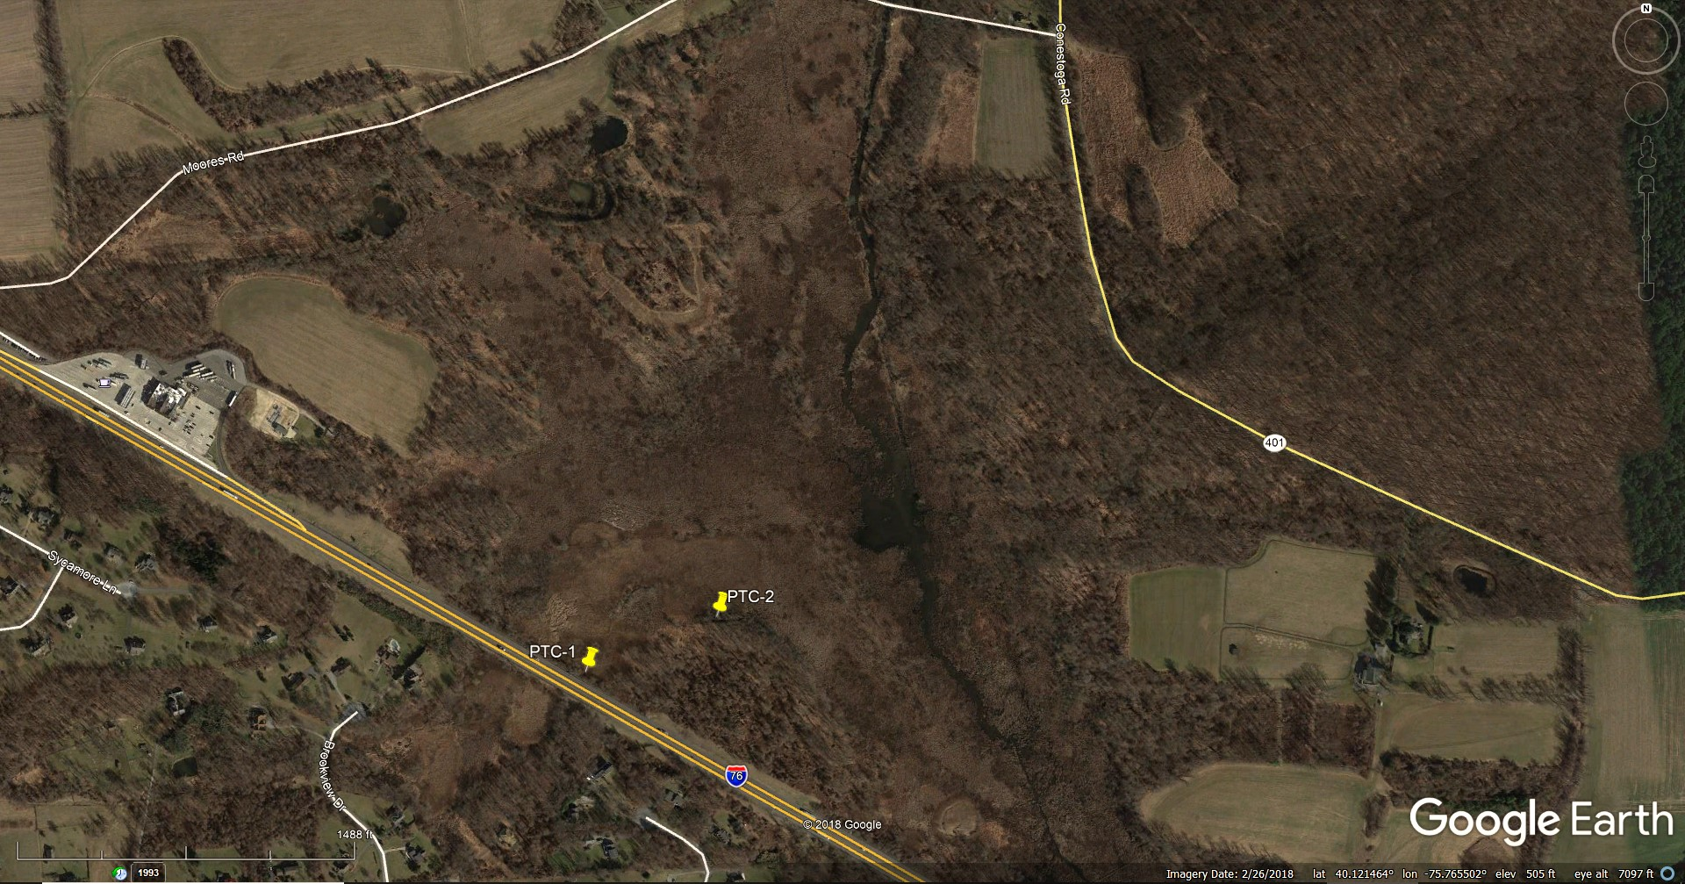
PTC-1 N 40.118625, W 75.769653
PTC-2 N 40.118625, W 75.767538

